5 SQL categories in database
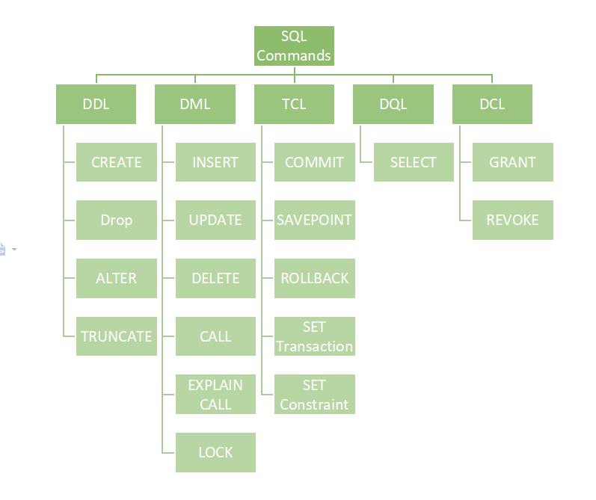
- DDL – Data Definition Language
  - To create/remove/alter tables. Involve the definition of schema.
- DML – Data Manipulation Language
  - To manipulate data inside a table
- TCL – Transaction Control Language
  - Control on transactions, i.e. how to make multiple queries together
- DQL – Data Query Language
  - To pull data from tables
- DCL – Data Control Language
  - To define permissions

